MESS FUNDING APPLICATION FORM
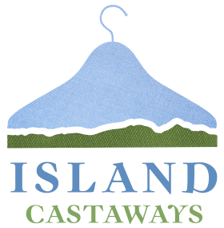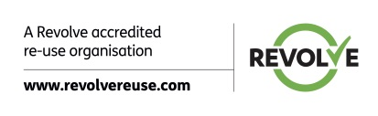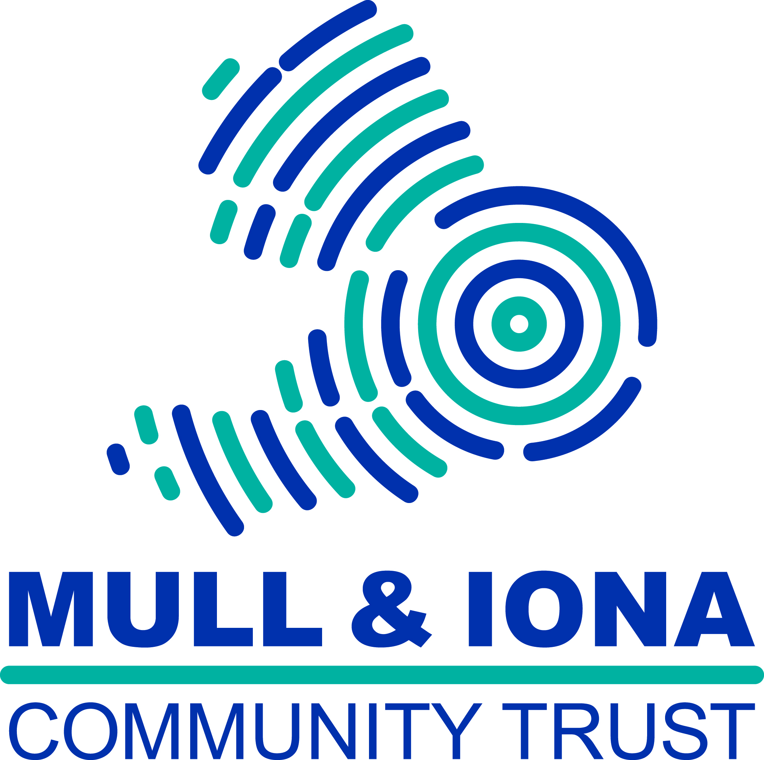
MESS (Mull & Iona Environmentally Sensitive Solutions) operates three charity shops ‘Island Castaways’ as part of our commitment to reduce waste and encourage re-use of items. Once the cost of operating the shops has been met, the profits are distributed to local community groups and also used to directly support the work of Mull and Iona Community Trust. Any voluntary group based on Mull, Iona or associated islands may apply to MESS for support. MESS funds cannot be allocated to private businesses or for party political purposes.
Island Castaways is part of the MESS project which is operated by Mull and Iona Community Trust (Scottish Charity Number: SC025995)

Name of group/organisation applying
Key contact and position within group/organisation
Correspondence Address

Email Address
Daytime Telephone number

What does your group plan to do?

When do you intend to start the project?
Who will benefit from project?(age range etc)
How much will the project cost to run?
How much have you raised already?
How did you raise the money? Or how do you plan to raise funds?
How much grant would you like to apply for( £500 max)
How does your group/organisation currently promote recycling within your group/organisation?

Who should a cheque be made payable to? (we are cannot make cheques out to individuals)

Conditions of the grant are that:

- A brief report of how the funds were spent, with a supporting photograph if appropriate, (with the necessary permissions) be sent to Hazel Cowe, Charity Shop Manager at hcowe@mict.co.uk . Photographs may be used by MESS or the Mull And Iona Community Trust to demonstrate the wider benefits of their work.
- Your organisation acknowledges the grant in a local press article, on your website, facebook page or including our logo on any printed material created as a result of the grant.

