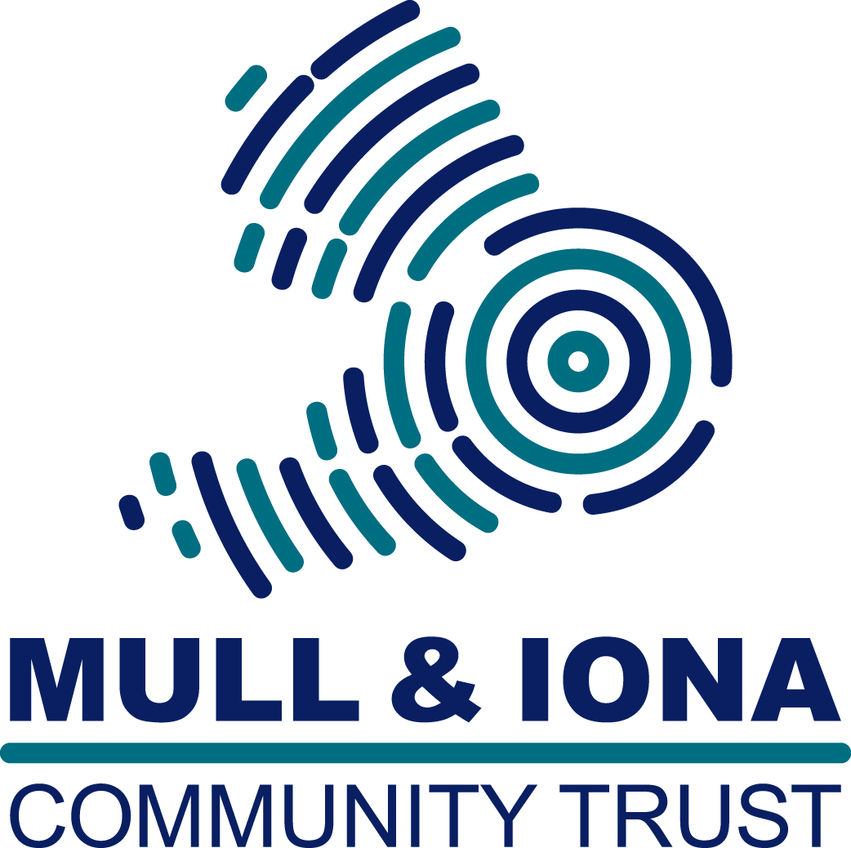 Mull and Iona Community Trust

Sustainable Mull and Iona

Meeting Wednesday 20th April, 7.30pm

An Roth, Craignure

Notes of the meeting

Attendance: David Pollard (chair); Carol Aldred; Derek Crook; Steve Littlewood; Terry Hegarty. Apologies were received from: Sandy Brunton, Celia Royce, Nigel Burgess

- Welcome
The Chairman welcomed everyone to the meeting

2) Notes from last meeting.
a) MICT has forwarded a copy to DP of the final report of the Mull and Iona Sustainable Transport (MIST) report, with the proviso that it should not be circulated without further discussion.
b) The Fionnphort electric charge point has been installed but not yet connected up.
c) The Wild Mull meeting is on Sunday 24th April, Craignure Hall. More than 80 people have registered to attend.
d) The battery bank has still not been returned from Glengorm to Bunessan. DP to chase up.

- Zero Waste Funding

DP reported that the Funding meeting with MICT had been re-scheduled for Monday May 2nd. He would report back its conclusions at that next meeting. The Zero Waste Scotland web site suggests promoting the bio-economy (food waste recycling). TH mentioned the bid proposal from Bute which was in competition with the MICT one, but it too may have lost out because it was a social enterprise rather than a partnership with the local authority. Subsequently ZWS suggested to Bute that they could fund micro-anaerobic digestion, but only in part. Technically MAD is what Mull would like to do but the economics don’t stack up. When the landfill site is closed food waste will have to go off the island. DP asked to check whether Nigel Burgess’s Cousin is still involved with MAD and follow up the current landfill tax situation.
A wide ranging discussion followed. TH reported that the Scottish Islands Federation were appointing a development officer who hopefully would know something about generating funding.
It was noted that there were still compost bins available at Glengorm tip and agreed that the info would be put up on SMI and Buy, Sell and Everything on Mull.

- ACCESS Update

CA said that the ACCESS Partnership were finalising their first year report. When it is issued she hopes to make a presentation to SMI about progress and the findings so far. In summary, 70 properties have been fitted with storage heaters. 10 are in completion and 3 have ‘issues’. The final total is expected to be 83 across a range of sectors. Problems around broadband issues are steadily being fixed. The project is due to report on 23rd May and there are plans being made to provide some Community training. The intention is to connect Garmony Hydo with the system in the autumn of this year.

There followed a general discussion about how to deal with issues raised through different individual usages

- Affordable Warmth

Michelle McGowan sent in the following report:-
This year the project has 206 new clients over Argyll, with 67 of these receiving benefit checks for income maximisation and a further 174 clients receiving house visits, to best assess the ways in which we may be able to help either reduce/write off fuel bills/debt, access energy efficiency programmes for insulation or heating measures.
With a case specifically on Mull, recently I have been successful in writing off a large fuel debt for a client, who unfortunately suffered a boiler breakdown over the winter months. In addition to the debt write off, the client was helped to change to a cheaper tariff for their energy needs and referred through to our Area Based Insulation Scheme (HEEPS-ABS) for insulation measures and referred to our in house advisor for a benefits check. In total the client has now saved over £800 and will make future further savings due to the insulation measures.
Over the next coming weeks and months, it’s hoped that we will be able to help more people on Mull that may be suffering fuel poverty via our workshops on fuel poverty to the public and with our specific workshops for health professionals with our Affordable Warmth for health advisor. I look forward to sharing more details of these with you soon.
Michelle asked that she be informed of anyone who people thought needed her help. There is a need to access as many people in fuel poverty as possible.

- HEEPS – ABS

Rachael McNicol submitted the following report:-
Ali-Energy is continuing to survey on Mull and Iona however any new surveys will not progress to install until early June once the 2016-17 scheme has been approved by Scottish Government. We are working up a promotion plan for 2016-17 as promotion and survey work will be staggered throughout the year to allow for an intensive push in each of the areas. If you know of any key events and/or meetings we should attend please send me details. Rachael has been talking to the Health and Wellbeing Network co-ordinator covering Mull and they are planning series of information days throughout the island in May (TBC) which we will be involved with to raise awareness of the scheme and our affordable warmth work. When I have more details I will let you know.

- Other items

- There was a discussion about the future for electric vehicles on Mull and Iona following the end of the MIST project. Sadly there will not be a follow up. TH is now running the Community Transport scheme on the Ross of Mull.
- All the compost bins in Craignure and Bunessan Castaways have been taken. DP to ask Hazel to bring down some more.

The next meeting of SMI is on 25th May, An Roth, 7.30 pm. All welcome.

David Pollard, Chairman SMI

