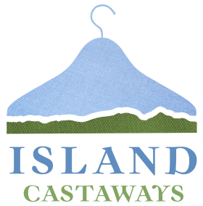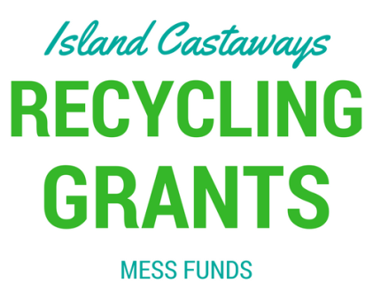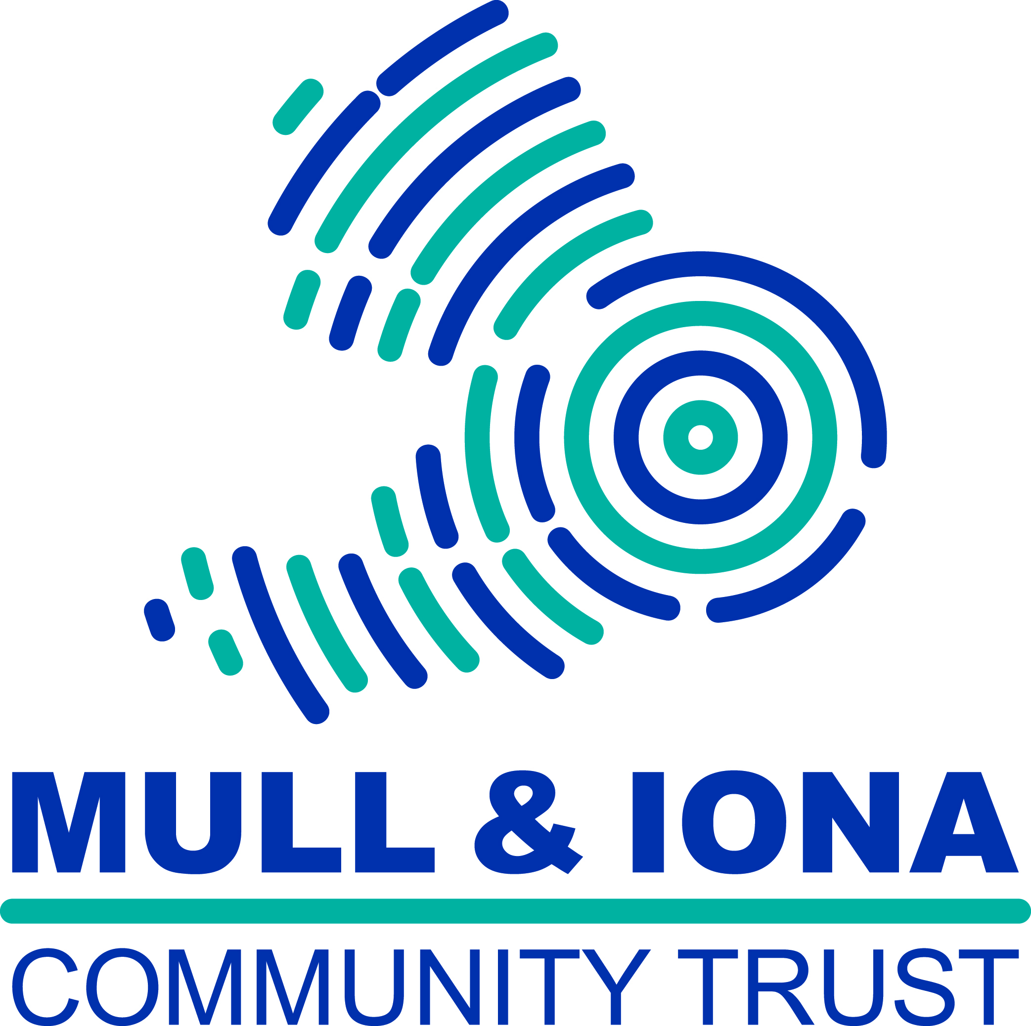
To celebrate Mull and Iona Community Trust’s 20th Birthday this year, we are offering a brand new grant in addition to our regular MESS Funds. Island Castaways Recycling Grant will be offering £1000 to community projects that benefit recycling on Mull and Iona. Projects must be run on a not for profit basis. We invite projects that find innovative solutions and fresh ideas to recycling in the community. Funding can be used to purchase equipment, contractors, materials and promotion.
Island Castaways is part of the MESS project which is operated by Mull and Iona Community Trust (Scottish Charity Number: SC025995)

Project Title
Total Cost of Project
Name of organisation applying

Type of organisation
This can be a business, individual, charity, voluntary group, sports group, community council, school, church, village hall or public body but the project must be not for profit.

Key Contact & Position
This is the person who we will keep in touch with throughout the project and send correspondence to. Please also tell us your role in the organisation

Email Address
Please give us an email address where the inbox is closely monitored.

Daytime Telephone Number

Correspondence Address
Please give us the address where letters and cheques can be sent to.

Your Recycling Project

Include detail about what you plan to do, where, timescales, who is involved, what the benefits are and why your project is a really good idea.

This is the most important part of your application and the more detail you can give, the better.

Your application will be marked against the following criteria:

1. Creativity & Innovation
2. How achievable the project is
3. How big an impact the project has on recycling on Mull or Iona
4. How well the project will educate people about recycling
5. How many people will benefit

This part of your application can include text, photos, plans or videos. We would love to see some creative ways of telling us about your project.

Top Tips!

Focus on how you will use the money you are applying for.

Start early and give yourself plenty of time to gather information and write your application.

Make it factual: how, when, how many, how much rather than why you want to do this project or why it’s needed.

Check your application, get someone else to read through it before submitting.

If you have any questions, we want to help! Get in touch by calling, emailing or visiting us.

Please give a breakdown of the cost of your project.  If you are successful, you will be required to provide full evidence of how the funding was spent with receipts.  Funding can be used to purchase materials, equipment, contractors, venue hire, marketing and reasonable volunteer expenses.  It is helpful to get quotes for work to submit with your final application. | Item including link if purchasing online. | Preferred Supplier | Cost

How will the project be managed?

Please tell us who the project will be managed by and whose responsibility it will be to ensure the project goes ahead.
Please tell us about your organisation’s current recycling efforts

Has your organisation ever received MESS Funding before? If so, please tell us for which project and when.

Conditions of the grant are that:

- a report of how the funds were spent with supporting photographs, (with the necessary permissions) should be sent to Laura Percy at lpercy@mict.co.uk . Photographs may be used by MESS or the Mull And Iona Community Trust to demonstrate the wider benefits of their work.
- Your organisation acknowledges the grant in local press, social media and on any promotional material including signs.

Signed

Print name

Date

Please return to Laura Percy:

Mull and Iona Community Trust
An Roth Community Enterprise Centre
Craignure
Isle of Mull
PA65 6AY

